Spring Data JPA - Quick Example

Output:

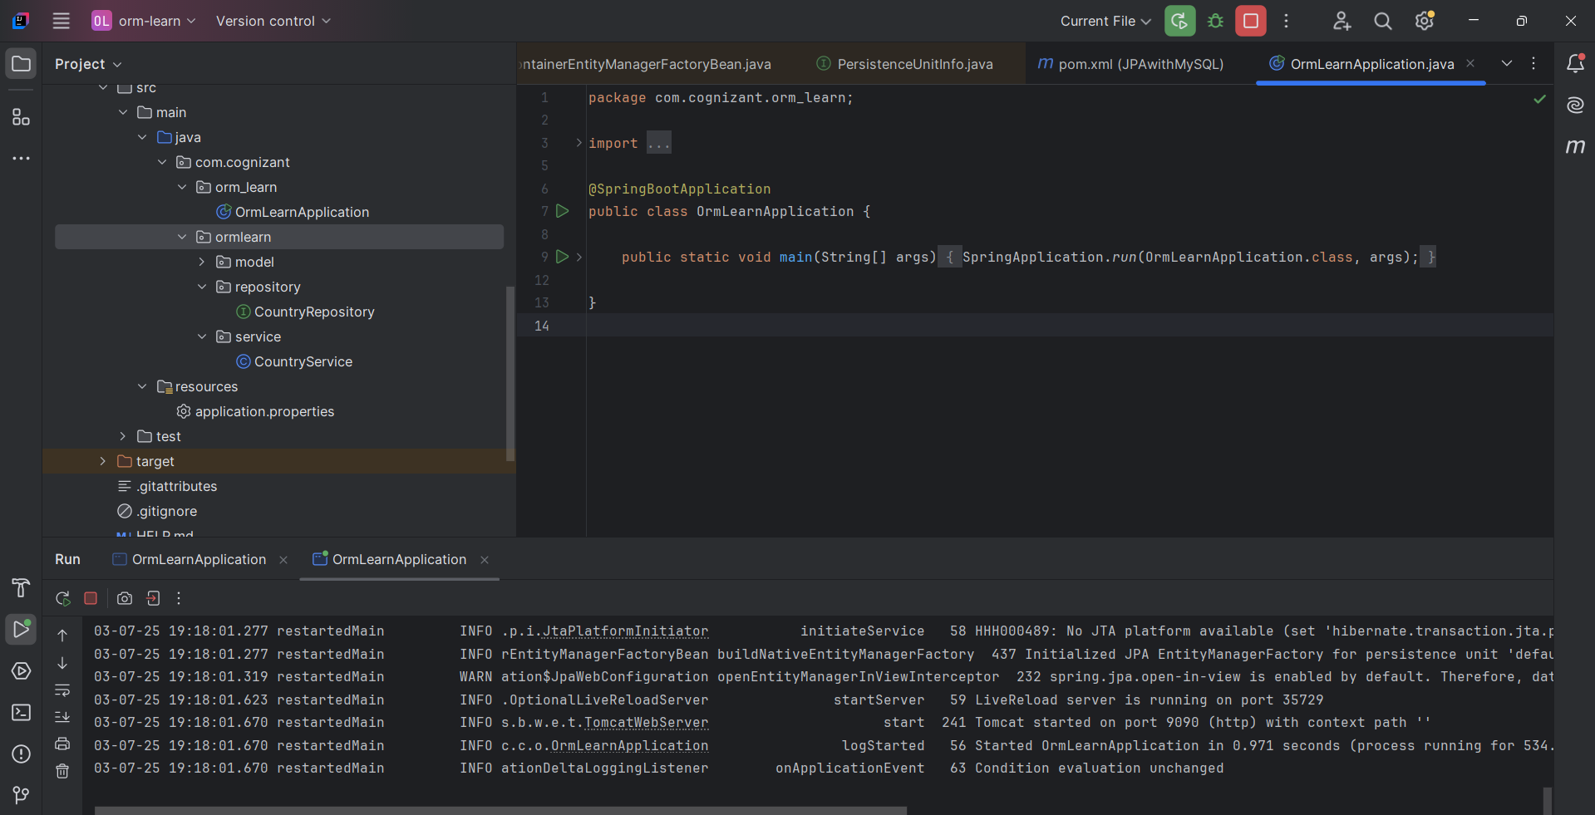

Code:

[Hands on 1](https://drive.google.com/drive/folders/182AfzkPDPjn_cQ8QlHGYPWIex9ePswWn?usp=sharing)